**[0] 04/19/2018**

**Alan Groff**



Structural Design

(Inside View)

**Vertical corrugation**

Design#:

**180508-02**

Customer:

**DeMet's Candy**

Description:

**610 11" max 7pk heart**

|  |  |  |  |  |  |  |  |  |  |  |  |  |  |  |  |
| --- | --- | --- | --- | --- | --- | --- | --- | --- | --- | --- | --- | --- | --- | --- | --- |
|  | 51*/*16 | |  |  |  |  |  |  |  |  |  |  | **SINGLE-OUT DRAWING** | |  |
|  |  |  |  |  |  |  |  |  |  |  |  | Qty/Unit: | |  |  |
|  |  |  |  |  |  |  |  |  |  |  |  | Style: | **32BK** |  |  |
|  |  |  |  |  |  |  |  |  |  |  |  |  |  |
|  |  |  |  |  |  |  |  |  |  |  |  | Board: |  |  |
| 161*/*16 | |  |  |  |  |  |  |  |  |  |  | Combination: **35HP - 23M - 35HP** | | |  |
|  |  |  |  |  |  |  |  |  |  |  |  | I.D. : | **10+1/2 x 10+1/4 x 10+7/8** | |  |
| 11 | | |  |  |  |  |  |  |  |  |  |  |  |  |  |
|  |  |  |  |  |  |  |  |  |  |  |  | Area of Blank - Waste : | | **4.73 sq. ft.** |  |
|  |  |  |  |  |  |  |  |  |  |  |  | Waste on Blank : | | **2.01%** |  |
|  |  |  |  |  |  |  |  |  |  |  |  | Finished Piece Weight: | | **0.49 lbs./221.12g** |  |
|  |  |  |  |  |  |  |  |  |  |  |  | Over-all Blank: **161/16** **x 431/4** | | |  |
|  |  |  |  |  |  |  |  |  |  |  |  |  |  |  |  |

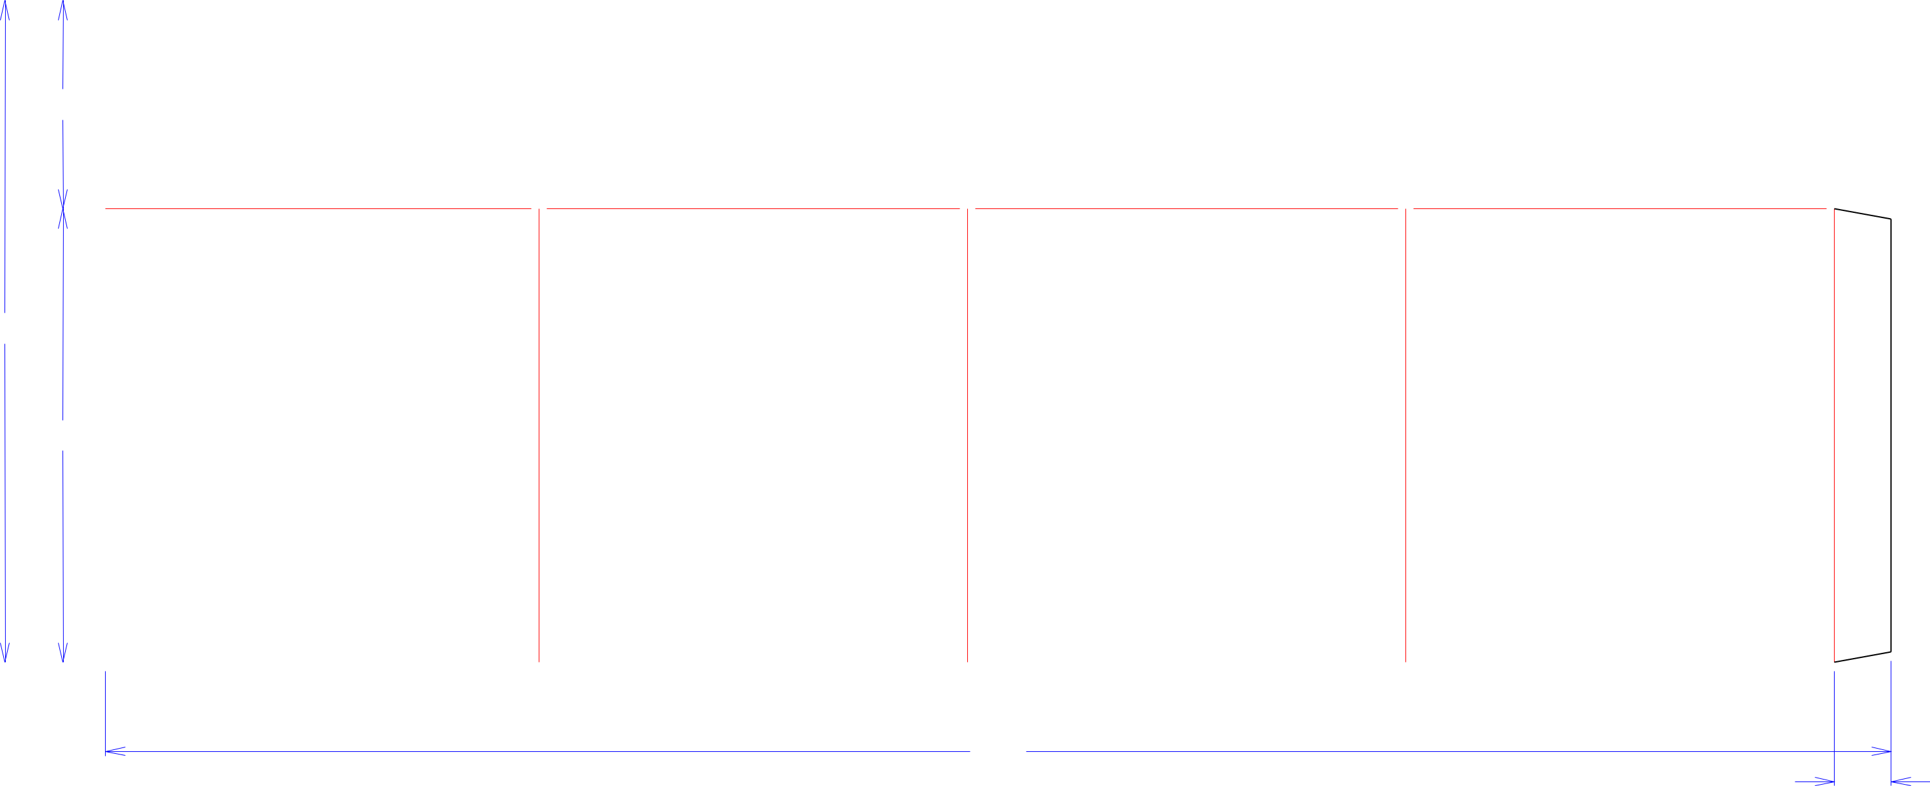

 101*/*2  103*/*8  105*/*8  103*/*8 

431*/*4

13*/*8

Notes:

**9001188**

Revision Info:

Designer:

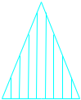

Cut Crease Crease with Matrix Cut Crease Half Knife Cut Tear Tape Perforation



Designright and Copyright of DS Smith Corrugated Packaging Ltd. This technical Specification is subject to Manufacturing tolerances. Drawing dimensions shown are crease to crease. Date printed: 08/08/2018